AP Media presents…

TECHNOLOGIES OF THE SOUL
Ancient Wisdom in the Smart Nation

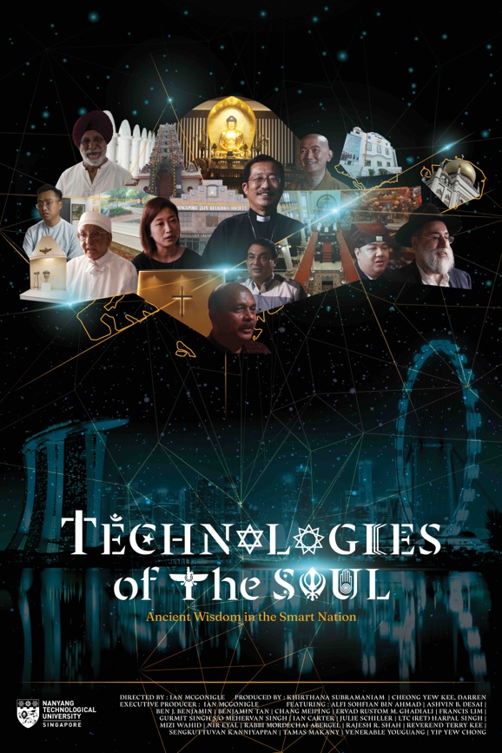

LOGLINE
Technology has disrupted our lives and rapidly transformed our societies, but Asia’s ancient spiritual traditions may have the wisdom to preserve the good life.
Contact: ianmcgonigle@ntu.edu.sg

SYNOPSIS
We have become entangled with technology more than ever. The distinctions between work and home, between leisure and labor, and between focus and distraction, are progressively blurring. How should we respond to this crisis and from where might we find the wisdom to regulate ourselves from the onslaught of digital creep? One source of wisdom is to be found with the world’s ancient faith traditions. This film engages the practices and habits of community leaders and practitioners of Singapore’s major faith groups, in one of the world’s most technologically advanced nations. Technologies of the Soul shows us how Asia’s ancient traditions have adapted rituals, sacrifices, prayers, and sabbaticals – and other techniques of the self – to create space outside of time to maintain peace and serenity.

RT: 60 min
OUTPUT: 4K (DCP; ProRes)

DIRECTOR STATEMENT
All of a sudden, the room went dark, but we continued to sit at the dinner table and chat about the weekly bible portion into the night. Since orthodox Jews are not permitted to operate electrical technology during the weekly sabbath, the lights were set by a timer to go off when it was time to sleep. While spending a year in Israel doing anthropological research for my PhD on Jewish national identity formation, I became fascinated with the ways ancient religious traditions have adapted to integrate technology with their longstanding beliefs and practices. A few years later, after I started a job as an Assistant Professor of Sociology in Singapore – the so-called Smart Nation – I began learning about the tremendous religious diversity of the island. I was curious to find out about how Asia’s traditions have responded to recent technological developments. This film is the product of interviews with leaders and practitioners of Singapore’s ten officially recognized religions, along with expert and scholarly perspectives on technology and the good life. I hope that by understanding the techniques of the self that have been preserved for thousands of years, we may be better prepared to embrace today’s technological potentials while maintaining the good life.
Ian McGonigle

FILMMAKER BIOGRAPHY
Ian McGonigle - Director
Ian McGonigle was born in 1984 in the town of Drogheda in the Republic of Ireland. His father was an electrician and his mother ran a pre-school. He grew up in the small town of Skerries in North County Dublin where he spent his youth racing sailboats. He was educated at Skerries Community College and at Trinity College Dublin, where he studied the sciences. Upon graduation, he went up to King’s College Cambridge for a PhD in biochemistry where he became distracted by anthropology, leading him to a masters in anthropology at the University of Chicago, and a second PhD, in anthropology and Middle Eastern studies, at Harvard University. His dissertation, ‘Genomic Citizenship,’ was awarded the Association for Middle East Anthropology dissertation award and became a book published with MIT Press. In 2018, he took up a Nanyang Assistant Professorship at NTU in Singapore with a grant to launch a ‘Science and Society’ research group. His first documentary film, Redemption: Wine and Prophecy in the Land of Israel, won several awards at international and independent film festivals.

About AP Media
As one of ASEAN’s leading media and integrated marketing agencies, AP Media is committed to go above and beyond as your partner of choice for enterprises. AP Media specialises in interactive media, video content and business consultancy to bring you campaigns that will excite, engage and inspire.

CREDIT LIST
Directed By
Ian McGonigle

Produced By
Khirthana Subramaniam
Cheong Yew Kee, Darren

Executive Producer
Ian McGonigle

Filmed By
Jerry Tang

Director’s Assistants
Anshely Chin
Seah Jia Hui

Editor and Colourist
Jason Hau

Film Title Design
Chow Yin Mui
Sia Yuanyi

Supported By
Nanyang Technological University

